**Pizza Sales SQL Queries**

1. **KPI**
2. **Total Revenue:**

SELECT SUM(total_price) AS Total_Revenue FROM pizza_sales;

1. **Average Order Value:**

SELECT (SUM(total_price) / COUNT(DISTINCT order_id)) AS Avg_order_Value FROM pizza_sales;

1. **Total Pizzas Sold:**

SELECT SUM(quantity) AS Total_Pizza_Sold FROM pizza_sales;

1. **Total Orders:**

SELECT COUNT(DISTINCT order_id) AS Total_Order FROM pizza_sales;

1. **Average Pizzas Per Order:**

SELECT CAST(CAST(SUM(quantity) AS DECIMAL(10,2)) /

CAST(COUNT(DISTINCT order_id) AS DECIMAL(10,2)) AS DECIMAL(10,2))

AS Avg_Pizzas_per_order

FROM pizza_sales

1. **Daily Trend for Total Order**

SELECT DATENAME(DW, order_date) as order_day, COUNT(DISTINCT order_id) AS Total_orders

FROM pizza_sales

GROUP BY DATENAME(DW, order_date);

***Output:***

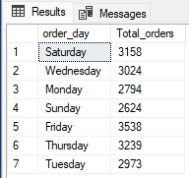

1. **Monthly Trend for Orders**

SELECT DATENAME(MONTH, order_date) AS Month_name, COUNT(DISTINCT order_id) AS Total_orders

FROM pizza_sales

GROUP BY DATENAME(MONTH, order_date)

ORDER BY Total_Orders DESC;

***Output:***

1. **% of Sales by Pizza Category**

SELECT pizza_category, SUM(total_price) * 100 / (SELECT SUM(total_price) FROM pizza_sales) AS PCT

FROM pizza_sales

GROUP BY pizza_category;

***Output:***

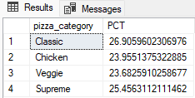

1. **% of Sales by Pizza Size**

SELECT pizza_size, CAST(SUM(total_price) * 100 / (SELECT SUM(total_price) FROM pizza_sales) AS DECIMAL(10,2)) AS PCT

FROM pizza_sales

GROUP BY pizza_size

ORDER BY PCT DESC;

***Output:***

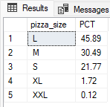

1. **Total Pizzas Sold by Pizza Category**

SELECT pizza_category, SUM(quantity) as Total_Quantity_Sold

FROM pizza_sales

GROUP BY pizza_category

ORDER BY Total_Quantity_Sold DESC**;**

***Output:***

1. **Top 5 Pizzas by Revenue**

SELECT TOP 5 pizza_name, SUM(total_price) AS Total_Revenue FROM pizza_sales

GROUP BY pizza_name

ORDER BY Total_Revenue DESC;

***Output:***

1. **Bottom 5 Pizzas by Revenue**

SELECT TOP 5 pizza_name, SUM(total_price) AS Total_Revenue

FROM pizza_sales

GROUP BY pizza_name

ORDER BY Total_Revenue ASC;

***Output:***

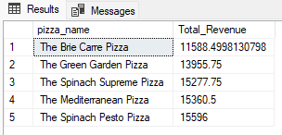

1. **Top 5 Pizzas by Quantity**

SELECT TOP 5 pizza_name, SUM(quantity) AS Total_Pizza_Sold FROM pizza_sales

GROUP BY pizza_name

ORDER BY Total_Pizza_Sold DESC;

***Output:***

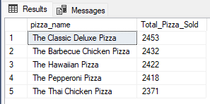

1. **Bottom 5 Pizzas by Quantity**

SELECT TOP 5 pizza_name, SUM(quantity) AS Total_Pizza_Sold

FROM pizza_sales

GROUP BY pizza_name

ORDER BY Total_Pizza_Sold ASC;

***Output:***

1. **Top 5 Pizzas by Total Orders**

SELECT TOP 5 pizza_name, COUNT(DISTINCT order_id) AS Total_Orders

FROM pizza_sales

GROUP BY pizza_name

ORDER BY Total_Orders DESC;

***Output:***

1. **Bottom 5 Pizzas by Total Orders**

SELECT TOP 5 pizza_name, COUNT(DISTINCT order_id) AS Total_Orders

FROM pizza_sales

GROUP BY pizza_name

ORDER BY Total_Orders ASC;

***Output:***

